MIDWEST INSURANCE
GenAIOps Foundation for the Policy & Process Guidance Assistant
Maturity assessment and 60-day plan · Operating loop and RACI · DataOps architecture and grounding controls
Prepared by | Dennis, GenAIOps Engineer
Prepared for | CIO; COO, Claims and Underwriting; CISO; Chief Compliance Officer; Platform and Data Engineering leads
Use case | Retrieval-augmented generation (RAG) assistant that gives claims processors and underwriters cited answers from approved policy and process guidance
Company profile | Regional insurer, ~2,500 employees, 12 states, $1.2B premium volume, existing Azure estate
Version / date | 1.0 · 12 October 2026
Classification | Internal
Companion file | Dennis_GenAIOps_Diagrams.pdf (all five figures at full size, vector)

Executive summary
MidWest Insurance wants an assistant that answers claims processors' and underwriters' questions from approved policy and procedure documents, with citations, so that guidance is applied the same way in all 12 states. Azure capability is not the constraint. Operational discipline is: today the pilot cannot show which document version supported an answer, cannot detect a drop in answer quality, and cannot stop runaway spend. This package sets out the GenAIOps foundation that closes those gaps.
Where we are. Level 1 (Initial) on the Microsoft GenAIOps maturity model in all four dimensions assessed: Evaluation, Monitoring, Governance and Cost Control (Figure 1).
The three gaps that matter most, and what each means for the business:
- No evaluation baseline or release gate. Prompt, model and index changes ship untested, so wrong-state guidance can reach a claim file unnoticed.
- No end-to-end observability or cost attribution. We cannot reconstruct why an answer was given, or see cost per answer.
- Ungoverned content lifecycle and access. Superseded documents stay retrievable, nobody owns freshness, and there is no tested way to delete personal data from the index.
Where we will be on Day 60. Level 2 (Defined) in every dimension: a 300-question golden dataset approved by subject-matter experts (SMEs), an automated release gate, every answer traceable to the exact source version, per-team token quotas, freshness service levels and a tested deletion runbook (Figure 2).
Why it matters now. The NAIC Model Bulletin on insurers' use of AI expects a written AI program with governance, risk management and documented controls, and examiners may ask for that evidence. About half of US states have adopted it, including Midwestern states such as Illinois, Iowa, Michigan and Wisconsin [3]. An assistant that informs claims and underwriting work falls inside that expectation even though a person makes every decision.
Decisions requested from leadership:
- Approve the 60-day plan and the named owners in Table 4.
- Approve azure-search-openai-demo, hardened as described in Section 2.4, as the application template.
- Nominate one claims and one underwriting content owner with authority to approve the golden dataset and attest source accuracy.

Scope, assumptions and evidence base
In scope: an internal question-and-answer assistant over policy forms and endorsements, underwriting guidelines, claims-handling procedures and state regulatory bulletins. It advises; a licensed person decides. Out of scope: customer-facing use, automated claim or underwriting decisions, and model fine-tuning.
Working assumptions (to confirm in week 1): ~650 claims processors and ~200 underwriters as eventual users; a corpus of ~15,000 documents (~200,000 chunks); an existing pilot serving 40 users in two states. The brief gives company-level facts only, so the current-state evidence below is the discovery baseline for this engagement: two weeks of interviews (IT, Claims Operations, Underwriting, Security, Finance) plus a review of the pilot repository, Azure subscription and cost exports. Each assessment rating cites an evidence ID.
ID | Discovery finding | Source
E1 | Pilot evaluated once with 25 hand-written questions scored pass/fail by one analyst; never re-run | Pilot repo; Innovation lead
E2 | No golden dataset; SMEs reported 14 wrong-state answers by email in 8 weeks | Claims Ops inbox review
E3 | Application Insights collects default request telemetry only; no retrieval or prompt traces, no cited document IDs | Subscription review
E4 | Only App Service health alerts; no quality, latency or token alerts | Azure Monitor review
E5 | Prompts hard-coded in Python and deployed by direct push; no version tags | Repo history
E6 | Users sign in with Entra ID SSO, but the app calls Azure OpenAI with an API key held in app settings | Configuration review
E7 | Documents uploaded by hand from a SharePoint export; 18 of 200 sampled indexed documents (9%) are superseded | Index sample audit
E8 | No content-owner list, no deletion process for indexed content, no Responsible AI (RAI) impact assessment | Compliance and Privacy interviews
E9 | AI spend visible only on the monthly invoice; shared subscription with 40% of resources untagged | Cost Management export
E10 | No token quotas; one batch test used about three times a normal week's tokens in a single day | Azure OpenAI metrics
E11 | Strength: Azure DevOps with release approvals already runs core applications | DevOps review
E12 | Strength: enterprise Log Analytics workspace and Microsoft Sentinel already in place | Security interview
Table 1. Evidence register (discovery baseline, October 2026).

1. Maturity assessment and 60-day improvement plan

1.1 Method
The assessment uses Microsoft's four-level GenAIOps maturity model (1 Initial, 2 Defined, 3 Managed, 4 Optimized) [1][2], applied per dimension rather than to the whole organisation. Each dimension has four Level-2 criteria. The score is the level fully reached plus the share of the next level's criteria met, so 1.25 means Level 1 with one of four Level-2 criteria in place. Scores are therefore traceable to evidence, not opinion.

1.2 Assessment by dimension
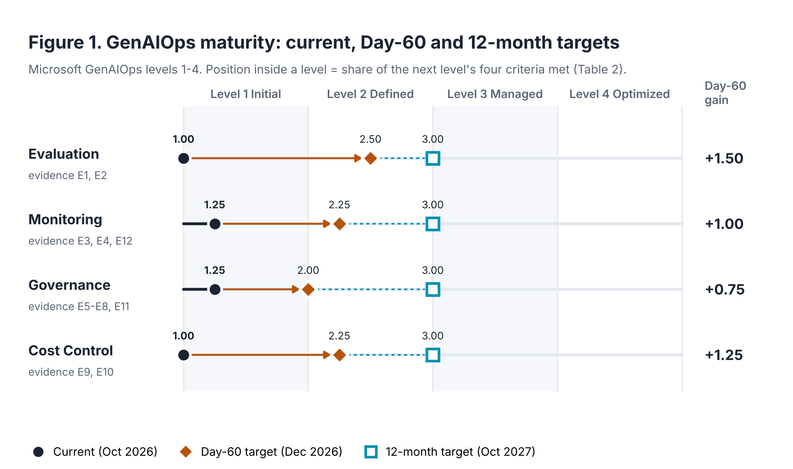

Dimension | Score | Evidence | Level-2 criteria (Met / Gap) | Day-60 target
Evaluation | 1.00  Initial | E1, E2 | Gap Versioned golden dataset  Gap Standard evaluators run repeatably  Gap Agreed pass thresholds  Gap Results recorded per release | 2.50: all four, plus automated gate and online sampling (Level 3)
Monitoring | 1.25  Initial | E3, E4, E12 | Gap RAG-aware traces (prompt, model, chunk IDs)  Gap Quality and ops dashboards  Met Basic operational alerts  Gap Token telemetry per consumer | 2.25: all four, plus quality alerts from online evaluation
Governance | 1.25  Initial | E5–E8, E11 | Met User access via Entra ID groups  Gap Prompts and config versioned, with release approval  Gap Named content owners and lifecycle  Gap RAI impact assessment; no shared keys | 2.00: all four
Cost Control | 1.00  Initial | E9, E10 | Gap Workload tagging  Gap Budgets with alerts  Gap Token metering per team  Gap Cost per answered query baselined | 2.25: all four, plus enforced per-team quotas
Table 2. Maturity scores with the criteria behind them. Twelve-month target: Level 3 (Managed) in all four dimensions.
Two strengths shorten the path: release approvals in Azure DevOps (E11) and a central Log Analytics and Sentinel estate (E12) can be reused rather than built.

1.3 Top three gaps
Gap | Dimensions | Risk if left open | Why it ranks here
1. No evaluation baseline or release gate | Evaluation | Untested changes reach users; wrong-state guidance (E2) goes unnoticed; no testing evidence for regulators | Highest consumer and regulatory impact; every other control depends on knowing what “good” looks like
2. No end-to-end observability or cost attribution | Monitoring, Cost Control | An answer cannot be explained after the fact; spend spikes (E10) are seen a month late | Needed to investigate complaints and to scale beyond two states within budget
3. Ungoverned content lifecycle and access | Governance | Superseded forms (9%, E7) cited as current; personal data cannot be removed; API key exposure (E6) | Accuracy of the corpus is the accuracy of the answers
Table 3. Prioritised gaps, ranked by consumer and regulatory risk against effort to close.

1.4 60-day improvement plan
Each gap gets one workstream. Days 1–20 establish baselines, Days 21–40 instrument and gate, Days 41–60 operationalise. Owners are roles so the plan survives staffing changes; named individuals are assigned at kickoff.
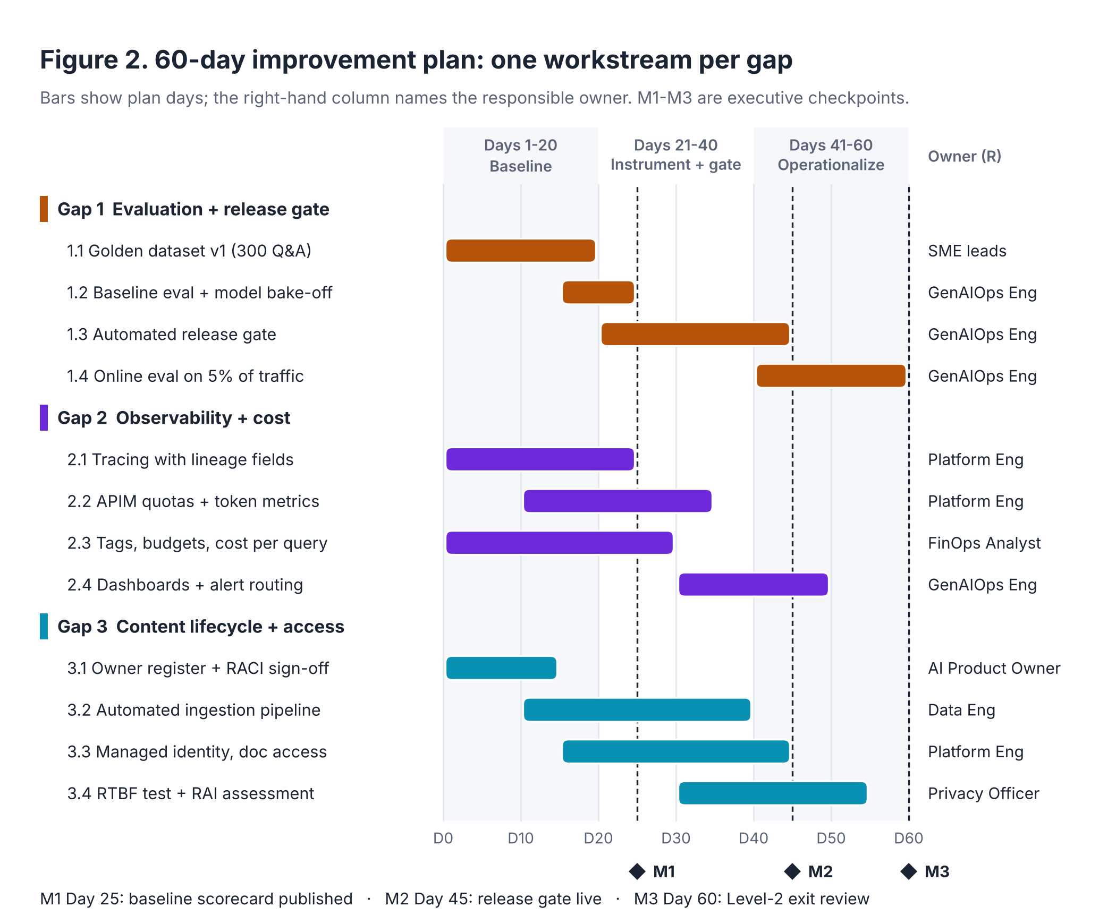

# | Action | Owner (R) / Accountable | Days | Success criterion at Day 60
1.1 | Build golden dataset v1: 300 Q&A pairs, at least 20 per state, including 30 that should be declined; each with expected source document IDs | Claims and UW SME leads / AI Product Owner | 1–20 | 300 pairs SME-approved and versioned in Git
1.2 | Run baseline evaluation with Foundry evaluators (groundedness, relevance, retrieval, document retrieval, safety) plus custom state-correctness; bake off two pinned chat models | GenAIOps Eng / GenAIOps Eng | 15–25 | Baseline scorecard published at M1 (Day 25)
1.3 | Add a release gate to Azure DevOps: every change to prompts, model, chunking or index runs the golden set and blocks on thresholds in Section 4.1 | GenAIOps Eng / AI Product Owner | 20–45 | 100% of production changes after Day 45 pass the gate (M2)
1.4 | Online evaluation on a 5% sample of production answers, scored weekly | GenAIOps Eng / GenAIOps Eng | 40–60 | Two weekly scorecards issued; drift alert tested
2.1 | OpenTelemetry tracing to Application Insights carrying prompt version, model version, index name, chunk IDs and token counts | Platform Eng / GenAIOps Eng | 1–25 | ≥ 99% of requests carry a complete trace
2.2 | Route all model traffic through the API Management AI gateway with per-team token limits and token metrics [11] | Platform Eng / Platform Eng | 10–35 | 100% of model calls via gateway; quotas active
2.3 | Enforce tags with Azure Policy, set budgets with 80% and 100% alerts, publish cost per answered query | FinOps Analyst / CIO delegate | 1–30 | 100% of AI resources tagged; cost baseline by Day 30
2.4 | Dashboards (quality, operations, cost) and alert routing to on-call | GenAIOps Eng / Platform Eng | 30–50 | Alerts fire within 15 minutes in a game-day test
3.1 | Content-owner register per collection and RACI sign-off | AI Product Owner / COO delegate | 1–15 | Owner named for 100% of collections
3.2 | Replace manual uploads with the automated ingestion pipeline and metadata contract (Section 3) | Data Eng / Data Eng | 10–40 | 0 superseded documents retrievable outside their dates
3.3 | Managed identities, key authentication disabled, document-level access trimming | Platform Eng / CISO delegate | 15–45 | 0 API keys in use; access test passes for 3 roles
3.4 | Deletion (RTBF) runbook tabletop test; RAI impact assessment approved | Privacy Officer / Chief Compliance Officer | 30–55 | Test request closed end-to-end in ≤ 5 business days; assessment signed
Table 4. 60-day plan. M3 (Day 60) is a Level-2 exit review against Table 2 with the same evidence method.

2. GenAIOps operating loop
The loop has two speeds. The inner loop is Query Serve: each request is authenticated, retrieved, grounded, generated, answered with citations and traced in seconds. The outer loop carries change: telemetry and sampled answers feed Evaluation, the scorecard decides whether a change ships, and approved changes re-enter through Ingest, Chunk and Index, Grounding or the model deployment. Nothing reaches users except through the outer loop's gate.

2.1 Phase-to-tool mapping and exit gates
Phase | Primary Azure services | Exit gate / control
1 Ingest | Azure Data Factory, Event Grid, ADLS Gen2 (versioned, immutable), Microsoft Purview, Azure Functions | Metadata contract passes; content hash and source version recorded
2 Chunk & Index | Azure AI Document Intelligence, chunking service, Azure OpenAI text-embedding-3-large (pinned), Azure AI Search | New index version built; document counts reconcile with manifest
3 Grounding | AI Search hybrid retrieval and semantic ranker, Entra document-level permissions [9], versioned prompt templates in Git, Azure AI Content Safety | Every answer cites a chunk, or the assistant declines
4 Query Serve (inner loop) | Azure Container Apps, API Management AI gateway, Foundry model deployment (pinned version), Entra ID, Application Insights | Trace complete; token quota respected
5 Evaluation | Microsoft Foundry evaluators [10], AI red teaming agent, Azure DevOps pipeline stage | All thresholds met; no metric regresses > 5%
6 Model / Content Update (outer loop) | Azure DevOps approvals, Bicep/azd, App Configuration version pins, AI Search index alias, Service Health retirement notices | AI Product Owner approves; release record lists every version
Table 5. Six phases, the Azure services behind them, and the control each must pass. Figure 3 (next page) shows the loop.

2.2 RACI
Phase | GenAIOps Eng | Data Eng | Platform Eng | Content owners | Security, Privacy, Compliance | AI Product Owner
1 Ingest | C | A/R | C | R | C | I
2 Chunk & Index | A | R | C | I | I | I
3 Grounding | A/R | C | I | C | C | I
4 Query Serve | R | I | A | I | C | I
5 Evaluation | A/R | C | I | R | C | C
6 Model / Content Update | R | R | R | C | C (veto) | A
Table 6. R = responsible, A = accountable (one per phase), C = consulted, I = informed. Compliance may block any release that changes regulated guidance.
Content owners are responsible in two places because only they can attest that a source is current (Ingest) and that an expected answer is correct (Evaluation). The AI Product Owner, not engineering, is accountable for release, which keeps go/no-go a business decision informed by the scorecard.

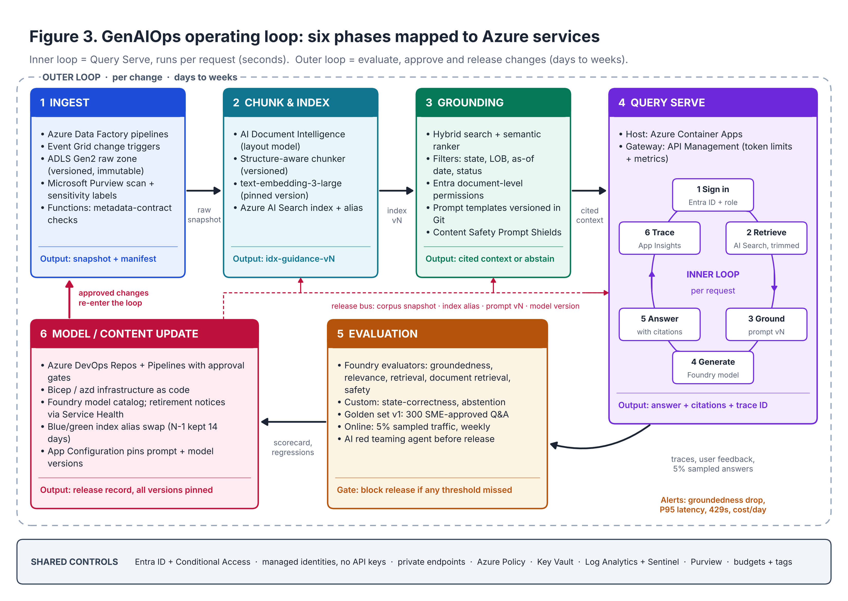

2.3 Accelerator template selection
Four starting points were scored against weighted criteria drawn from this use case. Scores run 1–5; weights sum to 100%.
Criterion (weight) | azure-search-openai-demo [4] | GPT-RAG [5] | genaiops-promptflow-template [6] | Build on Foundry SDK
Document Q&A with citations (20%) | 5 | 4 | 3 | 3
Document-level access control (20%) | 5 | 4 | 2 | 3
Built-in evaluation tooling (15%) | 4 | 3 | 4 | 3
Network isolation / zero trust (15%) | 3 | 5 | 3 | 4
Continuity with pilot and team skills (15%) | 5 | 2 | 2 | 2
Long-term supportability (15%) | 4 | 4 | 1 | 3
Weighted score | 4.40 | 3.70 | 2.50 | 3.00
Table 7. Template decision matrix.
Selected: azure-search-openai-demo, hardened. It is Microsoft's actively maintained RAG reference for Azure AI Search and Azure OpenAI, supports document-level access control through Entra ID, ships evaluation scripts, deploys with azd, and the pilot already runs on it, so the team keeps its code and skills. Its own documentation says it is a sample that needs production hardening, so three changes are mandatory: (1) adopt GPT-RAG's zero-trust pattern of private endpoints and no public data-plane access, (2) put API Management in front of the model, and (3) replace its manual evaluation step with the Foundry-based release gate in Azure DevOps.
Rejected: GPT-RAG is the stronger zero-trust landing zone but would re-platform a working pilot; we borrow its network pattern instead. The prompt flow GenAIOps template is ruled out because prompt flow in Microsoft Foundry and Azure Machine Learning retires on 20 April 2027 and is not recommended for new development [1].

3. DataOps architecture and grounding controls
The pipeline in Figure 4 (next page) has ten components. Components 1–4 bring approved documents in and reject anything incomplete or sensitive; 5–7 turn them into versioned chunks and embeddings; 8 serves them; 9 and 10 record lineage and enforce freshness, audits and deletion across every stage. Raw files are never edited in place: every change produces a new version with a new hash, which is what makes deletion and lineage provable.

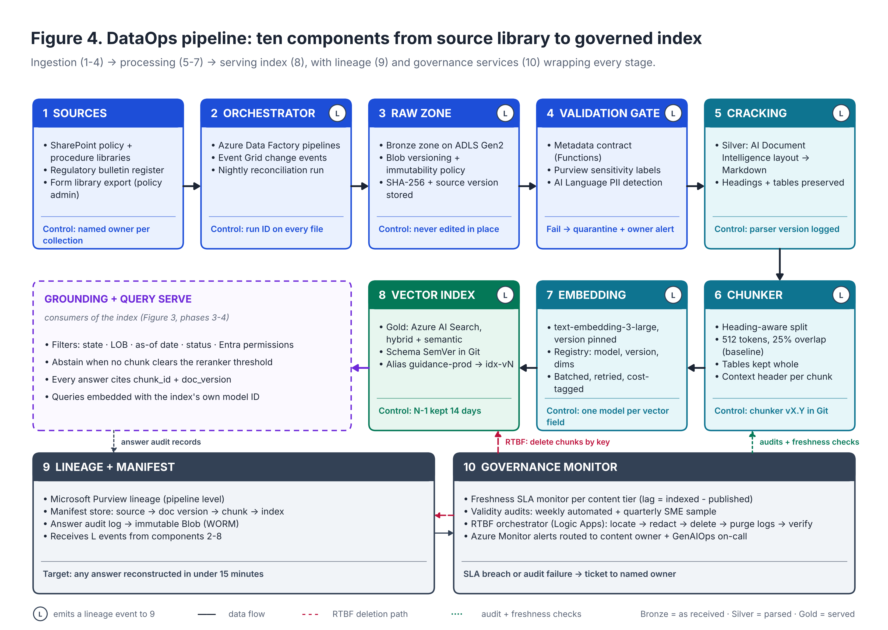

3.1 Chunking strategy
- Structure first, size second. Document Intelligence converts each file to Markdown; the chunker splits on headings (coverage part, section, clause), then by size. Starting size is 512 tokens with 25% (128-token) overlap, Microsoft's recommended baseline [7], tuned against the golden set.
- Tables stay whole (deductible schedules, limits, rating tables). Tables over 1,024 tokens split by row groups with the header row repeated.
- Each chunk carries a context header (form number, state, line of business, section path) and metadata: doc_id, doc_version, state, line_of_business, effective_date, expiry_date, status, content_owner, sensitivity_label, chunker_version.
- Chunk IDs are deterministic (hash of doc_id, version, section path and position), so re-runs are idempotent and changes diff cleanly. The chunker configuration is versioned (vX.Y); any change goes through the release gate.

3.2 Embedding model versioning
An embedding registry in Git records model, version and dimensions for each vector field (for example, text-embedding-3-large, version 1, 3,072 dimensions). Every chunk stores its embedding_model_id, and the application embeds queries with the model bound to the index it is querying. One vector field never mixes models. An upgrade builds a complete shadow index, compares it on the golden set, then swaps the alias. Microsoft gives at least 60 days' notice before retiring a generally available model [12]; retirement notices route to the GenAIOps on-call and open an outer-loop ticket. A full re-embed is about 120 million tokens, so a clean rebuild is cheaper than the risk of mixing.

3.3 Vector index schema versioning
Index schemas live in Git as JSON and follow semantic versioning. Major changes need a rebuild: vector dimensions, field type, analyzer or embedding model. Minor changes add fields in place. Patch changes adjust scoring or semantic configuration. Because most schema changes force a rebuild [8], indexes are named idx-guidance-v{major}-{date} and the application queries the alias guidance-prod, swapped only after the release gate passes. Index aliases are a preview feature [8]; until they are generally available, the active index name is pinned in App Configuration, with the same blue/green effect. The previous major version is retained for 14 days for rollback, and every answer logs the concrete index name, never the alias.

3.4 Freshness service levels
Tier | Content | Published → retrievable | Superseded → excluded | Owner
1 | State regulatory bulletins; mandated claims-handling changes | 1 business day, or before effective date if sooner | 4 hours | Compliance
2 | Policy forms and endorsements; underwriting guidelines | 2 business days | 4 hours | Product / UW lead
3 | Procedures, job aids, FAQs | 5 business days | 1 business day | Claims Ops lead
Table 8. Freshness SLAs. Lag = time indexed minus time published, measured per document; attainment reported weekly.
Policy forms are not deleted when superseded. A claim is handled under the form in force on the date of loss, so forms carry effective and expiry dates and the assistant filters by an as-of date, defaulting to today. Procedures, by contrast, are excluded once superseded. Future-dated documents are indexed with status = pending and become retrievable on their effective date.

3.5 Grounding controls
- Mandatory filters on every query: state, line of business, as-of date, status = active or in-date, and Entra document-level permissions, so an underwriting authority guide is never retrieved for a claims user [9].
- Hybrid retrieval with semantic ranking; if no chunk clears the reranker threshold, the assistant says no approved guidance was found and routes the user to the content owner rather than guessing.
- Every answer must cite at least one chunk; uncited answers are blocked. Prompt Shields screen user input and retrieved text for injection. The system prompt forbids coverage determinations.

3.6 Right-to-be-forgotten (RTBF) workflow
The corpus is guidance, not customer files, so prevention comes first: PII detection at the validation gate quarantines documents containing customer data, prompts are redacted before logging, and the golden set uses synthetic examples. When a deletion request does apply, the RTBF orchestrator runs:
- Intake. Privacy Office logs the request and verifies identity.
- Retention check. Legal confirms records-retention duties and legal holds; deletion may be limited to AI-derived copies.
- Locate. Query the manifest and logs by hashed identifiers to find doc, chunk, trace and evaluation-row IDs.
- Remove. Content owner redacts the source, which re-ingests as a new version; chunks are deleted by key from every live index including N-1; log records are removed with the Azure Monitor Delete Data API (Purge API only where required) [13]; evaluation and feedback rows are deleted; caches are flushed.
- Verify and close. An automated search for the identifiers returns zero hits everywhere; a deletion certificate goes to the Privacy Office.
Internal target: 15 business days, inside statutory windows that vary by state (commonly 45 days). Legal confirms which state privacy laws apply, since several exempt data already covered by the Gramm-Leach-Bliley Act.

3.7 Content validity audits
- Weekly, automated: superseded or expired documents retrievable outside their dates; orphan chunks whose source is gone; hash drift between source and index; metadata completeness (target 100%); near-duplicate chunks with conflicting guidance across states; broken citation links.
- Quarterly, SME: a stratified sample of 50 documents per collection plus the 100 most-cited chunks, attested by the content owner (target ≥ 98% valid).
- Event-driven: a regulatory change triggers the golden-set questions for the affected state before the new content is released.

3.8 Lineage traceability
Every hop from answer to source is a stored key (Figure 5): pipeline lineage in Microsoft Purview, request-level lineage in an answer audit log exported to immutable storage. The target is to rebuild the evidence behind any answer in under 15 minutes, which is what a complaint review or market-conduct examination will ask for.
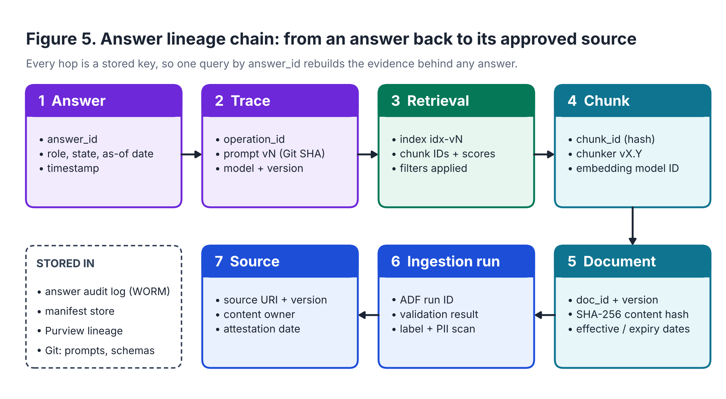

4. Success metrics and minimal operational controls

4.1 Success metrics
Area | Metric and definition | Day 60 | Month 6 | Source
Quality | Groundedness, mean on golden set (1–5) | ≥ 4.0 | ≥ 4.3 | Foundry evaluator
Quality | Groundedness pass rate | ≥ 90% | ≥ 95% | Foundry evaluator
Quality | Expected document in top 5 results | ≥ 0.80 | ≥ 0.90 | Document retrieval evaluator
Quality | State-correct citations | ≥ 97% | ≥ 99% | Custom evaluator
Quality | Correct declines on out-of-scope questions | ≥ 90% | ≥ 95% | Golden set
Quality | SME-validated citation accuracy (monthly sample of 100) | ≥ 95% | ≥ 98% | SME review
Operations | P95 end-to-end latency | ≤ 8 s | ≤ 5 s | Application Insights
Operations | Availability, 7 am–7 pm local, business days | ≥ 99.5% | ≥ 99.9% | Azure Monitor
Operations | Requests with a complete lineage trace | ≥ 99% | 100% | Application Insights
DataOps | Freshness SLA attainment (Table 8) | ≥ 95% | ≥ 99% | Governance monitor
DataOps | Superseded documents retrievable outside their dates | 0 | 0 | Weekly audit
DataOps | RTBF requests closed within internal SLA | 100% | 100% | Privacy tracker
Cost | Model cost per answered query (planning target; confirm against Day-30 baseline) | ≤ $0.04 | −20% vs baseline | APIM token metrics
Cost | Monthly spend vs budget | ± 10% | ± 5% | Cost Management
Adoption | Weekly active users in pilot cohort | ≥ 60% | ≥ 70% of all eligible | App telemetry
Adoption | Answers rated helpful | ≥ 80% | ≥ 85% | In-app feedback
Business | Median time to find guidance (time-and-motion study) | −30% | −40% | Claims Ops
Business | Guidance-related findings in claim-file QA reviews | Baseline set | −20% | Claims QA
Table 9. Release-gate thresholds are the first five quality rows at their Day-60 values; a release also fails if any quality metric falls more than 5% below current production.

4.2 Minimal operational controls
Area | Control | How it is enforced and evidenced
Access | Users authenticate with Entra ID and Conditional Access; only claims and underwriting groups are assigned | Entra access reviews every quarter
Access | Services use managed identities; key authentication disabled on Azure OpenAI, AI Search and Storage | Azure Policy deny rule; compliance dashboard
Access | Least privilege, with admin roles through Privileged Identity Management (just-in-time) | PIM activation log
Access | Document-level trimming by Entra group; private endpoints, no public data-plane access | Quarterly access test for three roles
Logging | Every request traced: prompt version, model version, index name, chunk IDs, tokens, latency, pseudonymous user ID, feedback | Trace completeness metric (Table 9)
Logging | Prompts and responses PII-redacted before logging; full text only in a restricted audit table | Redaction unit tests; PIM-gated access
Logging | Control-plane activity and diagnostics to central Log Analytics; security events to Sentinel | Diagnostic-settings policy
Logging | Each release stores its scorecard and version manifest | Azure DevOps release record
Retention | Operational telemetry: 90 days interactive | Workspace table retention settings
Retention | Answer audit log (lineage, no raw PII): per records schedule, assumed 7 years, on immutable Blob storage | Immutability policy; Records Management sign-off
Retention | Restricted full-text prompts and responses: 30 days, then automatic deletion unless on legal hold | Lifecycle policy
Retention | Source document versions: life of form plus retention period; index N-1: 14 days; golden sets and scorecards: life of system plus 7 years | Lifecycle policy; Git history
Table 10. Minimal controls in place by Day 60. Retention periods marked as assumptions need Records Management confirmation.

References
[1] Microsoft Learn. GenAIOps maturity model (includes prompt flow retirement notice, 20 April 2027). learn.microsoft.com/azure/machine-learning/prompt-flow/concept-llmops-maturity
[2] Microsoft Azure Blog. Achieve generative AI operational excellence with the LLMOps maturity model. azure.microsoft.com/blog
[3] NAIC. Implementation of NAIC Model Bulletin: Use of Artificial Intelligence Systems by Insurers, adoption map (status as of May 2026). content.naic.org
[4] Azure-Samples/azure-search-openai-demo. github.com/Azure-Samples/azure-search-openai-demo
[5] Azure/GPT-RAG solution accelerator. github.com/Azure/GPT-RAG
[6] microsoft/genaiops-promptflow-template. github.com/microsoft/genaiops-promptflow-template
[7] Microsoft Learn. Chunk large documents for RAG and vector search in Azure AI Search. learn.microsoft.com/azure/search/vector-search-how-to-chunk-documents
[8] Microsoft Learn. Update or rebuild an index; Create an index alias (preview). learn.microsoft.com/azure/search/search-howto-reindex and /search-how-to-alias
[9] Microsoft Learn. Document-level access control in Azure AI Search. learn.microsoft.com/azure/search/search-document-level-access-overview
[10] Microsoft Learn. Built-in evaluators and RAG evaluators in Microsoft Foundry. learn.microsoft.com/azure/foundry/concepts/built-in-evaluators
[11] Microsoft Learn. AI gateway in Azure API Management; llm-token-limit and llm-emit-token-metric policies. learn.microsoft.com/azure/api-management/genai-gateway-capabilities
[12] Microsoft Learn. Azure OpenAI model deprecations and retirements. learn.microsoft.com/azure/ai-services/openai/concepts/model-retirements
[13] Microsoft Learn. Manage personal data in Azure Monitor Logs (Delete Data and Purge APIs). learn.microsoft.com/azure/azure-monitor/logs/personal-data-mgmt
Diagrams were produced as code (Python/Matplotlib) so they can be versioned alongside the pipeline definitions; full-size vector versions are in Dennis_GenAIOps_Diagrams.pdf.

